**PORTABLE TABLE FANS:**

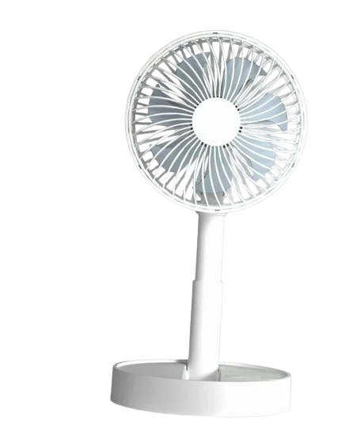

**Price: 5,000.00**

The Portable Table Fan is a convenient and versatile ventilation solution, designed to provide cooling relief wherever you need it. With its compact design, lightweight construction, and easy-to-carry handle, this fan can be effortlessly moved from room to room, desk to desk, or even outdoors. Its adjustable speed settings, quiet operation, and energy-efficient design make it an ideal choice for homes, offices, camping trips, and other settings where a portable and reliable cooling solution is desired.

**Key features of portable table include:**

* **Compact & Lightweight** – Easy to move and place in various locations.
* **Adjustable Speed** – Multiple settings for customizable airflow.
* **Quiet Operation** – Designed to operate quietly for minimal disruption.
* **Energy Efficient** – Consumes less power for cost-effective use.
* **Portable Power Options** – Can be USB, battery, or corded powered for flexibility.
* **Adjustable Tilt** – Allows airflow to be directed where needed.
* **Versatile Design** – Suitable for personal use in small spaces like desks, bedrooms, or offices.